# Concept of Information Communication Technology

Before we go in-depth with the concept of Information Communication Technology, we need to first understand the term **“Computer”**.

## What is a Computer?

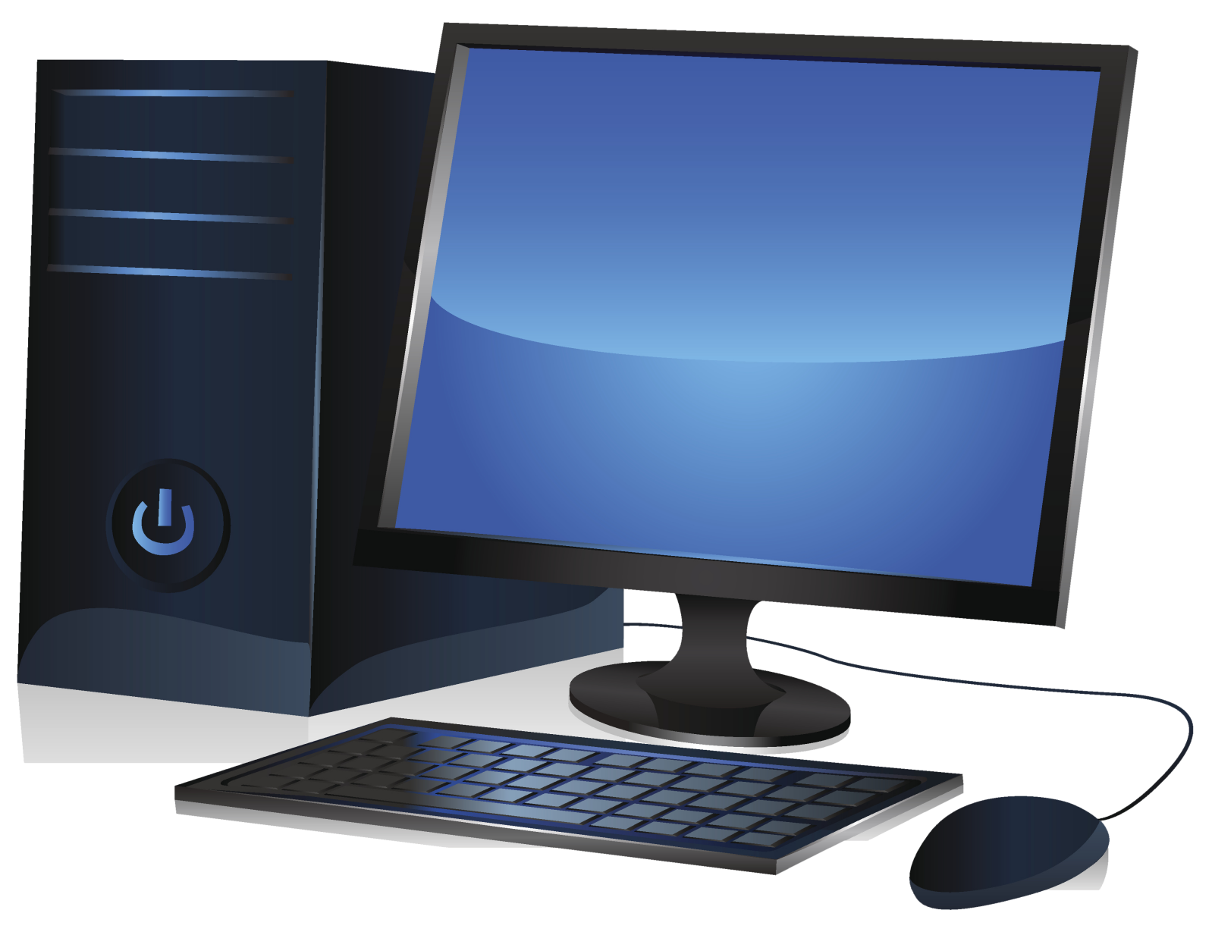

As we have regularly been told in school, that computer is an electronic device that collects **data**, **processes** the data in other to have useful **information**.

To further get the understanding of the computer we need to breakdown the three major concepts that make up a computer.

* Data
* Information
* Process

### What is Data?

Data are raw fact or unprocessed information.

### What is Information?

Information is the result we obtain after data is being processed.

### What is the Process?

The act of converting data into useful information.

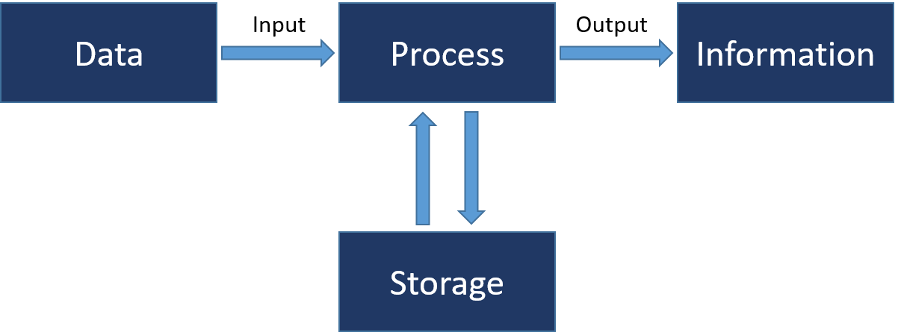

So, therefore, a computer is a machine that can be instructed to carry out a sequence of arithmetic or logical operations automatically using a computer program.

Now that we have a basic understanding of what is a computer and the major concept of a computer. We need to digest the terminology called **Information Technology**.

## What is Information Technology (IT)?

Information technology (IT) is the use of computers to **store**, **retrieve**, **transmit**, and **manipulate** data or information.

**IT** is typically used within the **context of business operations** as opposed to personal or entertainment technologies.

**IT** is considered to be a subset of information and communications technology (ICT).

An information technology system (IT system) is generally an information system, a communications system or, more specifically speaking, a computer system – including all hardware, software and peripheral equipment – operated by a limited group of users.

## What is Information Communication Technology (ICT)?

ICT, or information and communications technology (or technologies), is the infrastructure and components that enable modern computing.

Although there is no single, universal definition of ICT, the term is generally accepted to mean all devices, networking components, applications and systems that combined allow people and organizations (i.e., businesses, nonprofit agencies, governments and criminal enterprises) to interact in the digital world.

### Components of an ICT system

ICT encompasses both the internet-enabled sphere as well as the mobile one powered by wireless networks. It also includes antiquated technologies, such as landline telephones, radio and television broadcast -- all of which are still widely used today alongside cutting-edge ICT pieces such as artificial intelligence and robotics.

## Components of a Computer

Two major components make up a computer, which are

* Hardware
* Software

## Hardware

These are the physical aspect of a computer device that can be seen, feel and touch.

Examples are:

1. Monitor
2. Keyboard
3. Mouse
4. Central Processing Unit (C.P.U) /
5. System Unit (S U)
6. Printer
7. Projector
8. Scanner
9. Joysticks
10. Light Pen
11. Speakers etc.

### Monitor

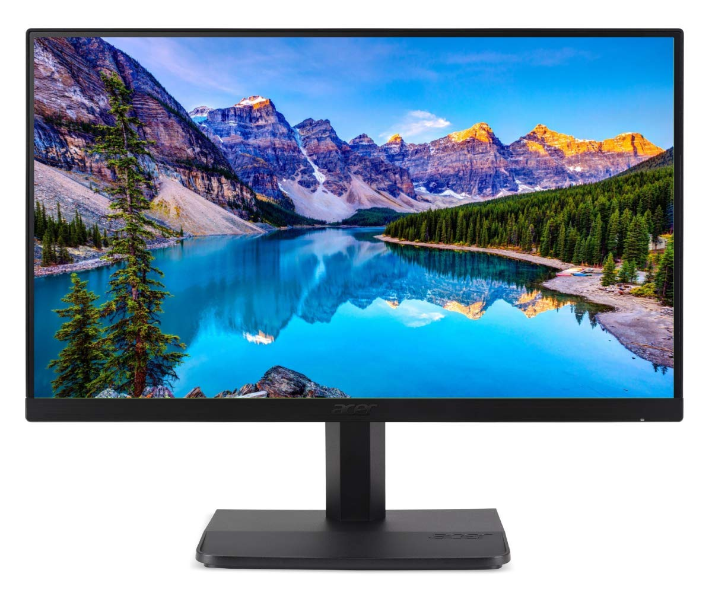

A computer monitor is an output device that displays information in pictorial form.

### Keyboard

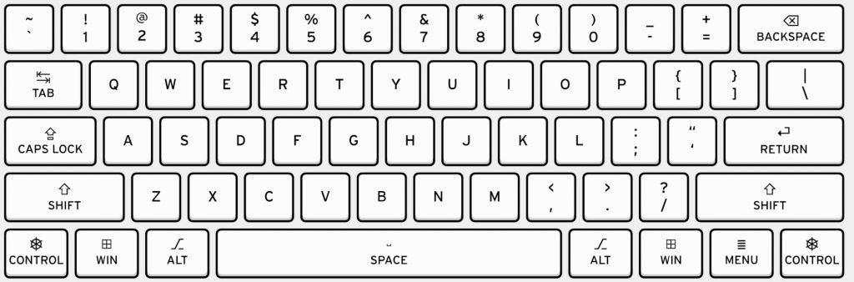

A keyboard is an input device that is used to enter data into the computer.

A keyboard comprises of alphanumerical characters, special characters and function keys. The current use keyboard is known as the **QWERTY** keyboard.

### Mouse

A mouse is a device used for controlling the arrow (cursor) which displays on the screen of a computer monitor or any other display unit of the computer.

They are two major types of Mouse

* Optical Mouse
* Laptop Mouse

#### Optical Mouse

The Optical mouse is the regular mouse we see which is detachable from a computer set. It has a **left-click button**, **right-click button** and a **scroll button** in-between.

#### Laptop Mouse

This type of mouse is a mouse that is attached to a computer mostly a laptop. It has a **left-click button**, **right-click button** and a **touchpad**.

#### Functions of The Left-click Button

It is used to select an object displayed on the computer screen

#### Function Of The Right-click Button

It is used to open an option box which contains various operations that can be performed on a document, file, folder, application etc.

### Central Processing Unit (CPU) / System Unit (SU)

CPU/SU is the enclosed box that contains most of the components of a personal computer (usually excluding the display, keyboard, and mouse).

Likely hardware found in a CPU/SU

* Motherboard
* CD ROM
* USB Ports
* RAM
* VGA Card

### Printer

The printer is a device used for outputting a hard-copy of a file.

### Scanner

A scanner is a device used for inputting a hard-copy file into a computer.

### Joystick

A joystick is an input device used as a controller for video games.

### Light Pen

A light pen is a computer input device in the form of a light-sensitive wand used in conjunction with a computer's display.

It allows the user to point to displayed objects or draw on the screen in a similar way to a touchscreen but with greater positional accuracy.

### Speaker

A speaker is used to output sound from a computer.

## Software

This is a collection of data or computer instructions that tell the computer how to work. In other words, they are set of instructions the computer uses to operate.

This is in contrast to physical hardware, from which the system is built and performs the work.

Computer hardware and software require each other and neither can be realistically used on its own.

Examples are:

* Operating System
* Microsoft Office
* CorelDraw Package
* Adobe Package
* Media Players etc.

### Operating System

An operating system (OS) is system software that manages computer hardware, software resources, and provides common services for computer programs.

The operating system is the most important software in a computer device. It’s a software that houses all other software.

Examples of OS are:

* Microsoft windows
* Macintosh (Mac OS)
* Linux
* Android
* I-phone Operating System (IOS) And Many Others

### Microsoft Office

The office is a collection of software or application used for office activities like writing a memo, typing a letter, creating inventory, storing data, creating a presentation, designing artworks etc.

They are seven (7) major applications in Microsoft office.

* Microsoft Word (MS Word)
* Microsoft Excel (MS Excel)
* Microsoft Access (MS Access
* Microsoft PowerPoint (MS PowerPoint)
* Microsoft Outlook (MS Outlook)
* Microsoft Publisher (MS Publisher)
* Microsoft OneNote (MS OneNote) And many more others.

#### Microsoft Word (Ms Word)

This is a word processing application using for typing documents like letters, memo, summary, books, etc.

#### Microsoft Excel (MS Excel)

Microsoft Excel is a spreadsheet document that uses a grid of cells arranged in numbered rows and letter-named columns to organize data manipulations like

arithmetic operations. It has a battery of supplied functions to answer statistical, engineering, and financial needs. It can display data as line graphs, histograms and charts, and with a very limited three dimensional graphical display.

#### Microsoft Access (MS Access)

Microsoft Access is a database management system (DBMS) that combines the relational Microsoft Jet Database Engine with a graphical user interface and software development tools.

#### Microsoft PowerPoint (MS PowerPoint)

Microsoft PowerPoint empowers you to create clean slide presentations and intricate pitch decks and gives you a powerful presentation maker to tell your story.

#### Microsoft Outlook (MS Outlook)

Microsoft Outlook is a personal information manager use for emailing, which also includes functions as calendaring, task managing, contact managing, note-taking, journal logging, and web browsing. Though,

its primary purpose is for sending and receiving mails.

#### Microsoft Publisher (MS Publisher)

Microsoft Publisher is a desktop publishing application differing from Microsoft Word in that the emphasis is placed on page layout and design rather than text composition and proofing.

#### Microsoft One Note (MS One Note)

In One Note, users can create notes that can include text, pictures, tables, and drawings. Unlike a word processor, One Note features a virtually unbounded document window, in which users can click anywhere on the canvas to create a new text box at that location. One Note saves data automatically as the user makes edits to their file.

# Using the computer and managing files

## What is an Icon?

An icon is a representation of a **file**, **folder** or an application mostly displayed on the desktop screen of a computer device.

### Moving an Icon

There are several ways of moving an icon around on a computer device.

Firstly, select the icon, then hold on to the **left-click button** while the cursor is on the icon. Move the mouse to your preferred location then release the **left-click button**.

### Opening an Icon

They are two (2) major method of opening an Icon

#### First Method

**Right-Click** on the Icon, a box of different operation that can be performed on the icon will be displayed then **left-click** on the word **Open**.

#### Second Method

**Double click (using left-click)** on the icon at a very fast speed (below a seconds), will automatically open up the icon.

### Using the Drag and Drop Method.

The drag and drop method is a similar way of moving the icon from one place to the other.

Firstly, select an icon, then hold on to the left-click button while the cursor is on the icon. Move the mouse to your preferred location then release the left-click button.

## Moving a window

Moving a window is an act of changing the active working environment to another.

They are different method of achieving this operation:

### First method

Selecting your preferred working environment from a list of an already open icon displayed on the **taskbar**.

### Second Method

You can change your active working environment by holding on to **Window+Tab** and select your preferred working environment.

### Third Method

You can change your active working environment by holding on to the **Alt Button** and continually pressing the **Tab button** until you reach your preferred working environment.

## Creating a new Folder or File

## What’s a File?

A file is a piece of a document found in the computer system.

### Creating a File

Firstly, **Right-click** on a space on desktop view on your computer, a box will appear showing a lot of different operation that can be performed. **Mouse-over** to new, another box will appear showing a lot of different operation that can be performed **Left-click** on any **Application File** or icon of your choice.

Immediately after **left-clicking**, a file will be created on the **desktop view** with an option of renaming the file. If you click elsewhere or press enter, it will automatically retain the name of the application.

***NB:*** *The same method can be used to create the file(s) inside a folder.*

## What is a Folder?

A folder is a container that houses file(s).

### Creating a new Folder

The same process of creating file can be applied to creating a folder with a little difference.

Firstly, Right-click on a space on desktop view on of your computer, a box will appear showing a different operation that can be performed. Mouse-over to new, another box will appear showing difference operation that can be performed Left-click on Folder.

Immediately after left-clicking, a folder will be created on the desktop with an option of renaming the folder. If you click elsewhere or press enter, it will automatically retain the phrase new folder.

**NB:** *The same method can be used to create the folder(s) inside another folder.*

## Rename, Paste, Cut and Copy

### Rename

They are different methods of renaming an icon.

#### First Method

Right-Click on the icon, a box will appear showing a different operation that can be performed. Left-click on rename. The name of the icon will be highlighted waiting for you to change to your preferred choice.

Change the name and press enter.

#### Second Method

Double click (using left-click) on the icon at a fast speed (at least more than a second), will automatically highlight the name, waiting for you to change to your preferred choice.

### Paste

This operation is used to place a cut, copy icon to a preferred location.

There are two (2) major method of pasting

#### First Method

Right-Click on the location, you want to place the icon, a box will appear showing difference operation that can be performed.

Left-click on paste. This will automatically the icon will be displayed on the preferred location.

#### Second Method

Navigate your cursor to your preferred location then press Ctrl + V. This will automatically the icon will be displayed on the preferred location.

### Cut

This operation is like slicing out a particular icon and placing it on a different location.

There are two (2) major method of cutting

#### First Method

Right-Click on the icon, a box will appear showing difference operation that can be performed. Left-click on Cut, this will make the icon looks blur at that position.

Navigate your cursor to your preferred location then paste. This will automatically transfer the icon to the preferred location.

#### Second Method

Select the Icon by left-clicking on it then press Ctrl + X. This will make the icon look blur at that position. Navigate your cursor to your preferred location then paste. This will automatically transfer the icon to the preferred location.

### Copy

This operation is like duplicating an icon and placing it on a different location.

There are two (2) major method of coping an icon

#### First Method

Right-Click on the icon, a box will appear showing a lot of different operation that can be performed. Left-click on Copy, on like the cut method, the icon will not look blur.

Navigate your cursor to your preferred location then paste. This will automatically create a replica of the icon on the preferred location.

#### Second Method

Select the Icon by left-clicking on it then press Ctrl + C. Navigate your cursor to your preferred location then paste.

This will automatically create a replica of the icon on the preferred location.

### Clipboard

This is temporal storage that holds your copy or cut icon. The Cut or Copy function shares the same clipboard. Which means when you copy an icon and later you cut and icon, it will replace the previous Icon in the clipboard.

**NB:** *A clipboard holds can only hold a single icon at a time.*

## Delete and select multiple icons (with the CTRL key)

### Delete

This operation is used to remove an unwanted icon from your computer.

Their two(2) major method of deleting.

#### First Method

**Right-Click** on the **icon**, a box will appear showing difference operation that can be performed. **Left-click** on delete, the icon will be deleted.

#### Second Method

Select the Icon by left-clicking on the keyboard (mostly at the top-right corner) press the key DELETE or DEL. Automatically the icon will be deleted.

**NB:** *Every Icon you delete go into the recycle bin.*

## Selecting Multiple Icon (with the CTRL Key)

Selecting multiple Icon can be done by simply holding down the CTRL Key and selecting the Icon with the left-click one after the other.

## Restore from the recycle bin

### What is Recycle Bin?

It’s temporal storage where deleted items are stored.

Restoring from the recycle bin is an act of returning Icon from the recycle bin back to the computer system for usage.

They are two(2) major method of restoring Icon from the recycle bin.

#### First Method

Open the Recycle Bin, Drag the Icon to your preferred location.

#### Second Method

Open the Recycle Bin, right-click on the Icon, a box will appear showing difference operation that can be performed. Left-click on restore, this will automatically return the icon to the previous location where the icon was deleted from.

### Empty the Recycle Bin

This operation will remove the icon permanently from the computer and the operation can not be restored.

They are two (2) major ways of emptying the recycle bin.

#### First Method

Open the recycle bin, you can select multiple icons or the one you want to delete permanently. Right-Click on the icon, a box will appear showing difference operation that can be performed. Left-Click on delete, an alert box will appear asking if you want to permanently delete icon with an option to select yes or no. Click yes this will automatically delete the icon without trace or means of restoring the icon.

#### Second Method

Open the recycle bin, you can select multiple icons or the one you want to delete permanently. on the keyboard (mostly at the top-right corner) press the key DELETE or DEL. An alert box will appear asking if you want to permanently delete icon with an option to select yes or no. Click yes this will automatically delete the icon without trace or means of restoring the icon.

**NB:** *Any item deleted from the recycle bin cannot be restored.*

## Create a Shortcut

### What is a Shortcut?

A shortcut is an icon on the desktop view of a computer created to have quick access to the application, folder or file that it represents.

There are two (2) major method of creating a shortcut.

#### First Method

Right-click on the icon you want to create a shortcut for, a box will appear showing a different operation that can be performed.

Left-click on Create Shortcut, a replication of the Icon will be created in the same location with a short blue arrow at the button left corner of the icon. Then you drag the created shortcut to your preferred location.

#### Second Method

**Right-Click** on the icon you want to create a shortcut for, a box will appear showing a different operation that can be performed.

**Mouse-over** to **Send to** another box will appear showing difference operation that can be performed **Left-click** on **Desktop (create shortcut)**.

Immediately after **left-clicking**, a replicate of the icon will be created on the desktop view.

## Compress (.Zip)

### What is a Zip?

A computer file whose contents are compressed for storage or transmission.

Zip is an archive file format that supports lossless data compression. A ZIP file may contain one or more files or directories that may be compressed.

### How to compress or zip

You can compress or zip a single icon or multiple icons together.

***NB:*** *Zip is a software that needs to be installed on a computer before it can be used. For the course of this class, we will be using WinRAR 5*

There is two (4) major method of compressing or zipping icon(s).

#### First Method (Add to archive)

Right-click on the icon, a box will appear showing a different operation that can be performed. Left-Click on Add to Archive.

Another Dialog box will appear with a different menu of operations.

**(General)**

This has a lot of options that can be used to select the type of operation that is need for the icon.

* Archive Name: This gives the option of changing the name of your archive to any preferred name of your choice. But at default, it will retain the name of the icon with the format extension of the compressor.
* Archive Format: There is a different format of compressing a file. Each is an updated version of the previous .RAR format which tends to be smaller and better than .ZIP.
* However, the overall compression in both formats depends on the size of the file. The .RAR 5.0 is a compression algorithm but still provides an option to create standard .RAR archives. This new version allows better compression for huge files.
* Set Password: This gives an option to set up a password that can be used to access the icon. It adds more security features to the icon.

After all, this setting has been made Left-Click on Ok. To create the compression.

#### Second Method (Add to “icon name.rar”)

Right-click on the icon, a box will appear showing a different operation that can be performed. Left-Click on Add to “iconname.rar”. This will automatically create the compression without a password.

#### Third Method (Compress and Email)

Right-click on the icon, a box will appear showing a different operation that can be performed. Left-Click on Compress and email... Another Dialog box will appear with a different menu of operations.

This method is similar to the first method (Add to archive) with a difference of creating a mail by opening your default mail application waiting to be sent.

#### Fourth Method (Compress to “iconname.rar and email)

Right-click on the icon, a box will appear showing a different operation that can be performed. Left-Click on Compress to “icon-name.rar” and email. This will automatically create the compression without a password.

This method is similar to the second method (Add to “icon name.rar”) with a difference of creating a mail by opening your default mail application waiting to be sent.

## Searching the Computer

Finding file, folder or software is becoming easier ever since the invention of window 7.

It helps save the stress of creating too much shortcut and finding it difficult to location icons.

To find an icon, Left-Click the window icon mostly at the bottom left corner of your computer display or click the Window key on your keyboard. A box will appear showing some of your icons, beneath the icon is a text field that allows entry of words.

## Control Panel

## What is the Control Panel?

The Control Panel is a component of Microsoft Windows that provides the ability to view and change system settings.

### Opening Control Panel

You can simply open the control panel by left-clicking on the Windows icon or pressing the windows key. Locate the text-field that allows entry of words. Type control panel.

Automatically a box will appear showing some of your icon of different adjustment that can be made on your computer system.

**NB:** *If the view by is on Category mode, this is the following icon you will see*

* System and Security
* User Accounts
* Network and Internet
* Appearance and Personalization
* Hardware and Sound
* Clock and Region
* Programs
* Ease of Access

### Changing Date and Time

Open up the control panel, click on Clock and Region. Two other option will appear which are;

* Date and Time
* Region

Click on Date and Time, another dialogue box will appear show Date and Time. Click on the button name Change date and time… another box will appear Titled Date and Time Settings. Change the date and time to your preferred setting.

### Changing the Background Image

Open up the control panel, click on Appearance and Personalization. Four other options will appear which are;

* Taskbar and Navigation
* Ease of Access Center
* File Explorer Options
* Fonts

Click on Taskbar and Navigation, another dialogue box will appear titled Settings.

Under personalization, left-click on the background. Change the image to your preferred option.

## Window Explorer/File Explorer

Window Explorer is the file management application in Windows OS.

Window explorer can be used to navigate your hard drive and display the content of the folder(s) and sub-folder(s) you use to organize your files on your hard drive.

Windows explorer is automatically launched any time you open a folder in your computer.

Window + E is another shortcut to open file explorer.

## Turning Off the Computer

There are many ways of turning off the computer

Open the start windows, on the left button of the start windows, there is an icon that looks like the power button. Left-Click on it automatically at least three options will appear showing different operation click on shutdown. This will turn off the system.

**NB:** *If there is any active working environment not yet close it will prompt you an option to close all or cancel the operation.*

Another way is by pressing Alt+F4 which will display the shutdown window. Click on OK

**NB:** *The Alt+F4 will only work if there is no active working environment.*

## Restarting the Computer

Restarting a computer is the same process as shutting down a computer.

Open the start windows, on the left button of the start windows there is an icon that looks like the power button. Left-Click on it automatically at least three options will appear showing different operation click on Restart. This will restart the system.

**NB:** *If there is any active working environment not yet close it will prompt you an option to close all or cancel the operation.*

Another way is by pressing Alt+F4 which will display the shutdown window.

Change the displayed option from Shutdown to Restart and click OK

**NB:** *The Alt+F4 will only work if there is no active working environment.*